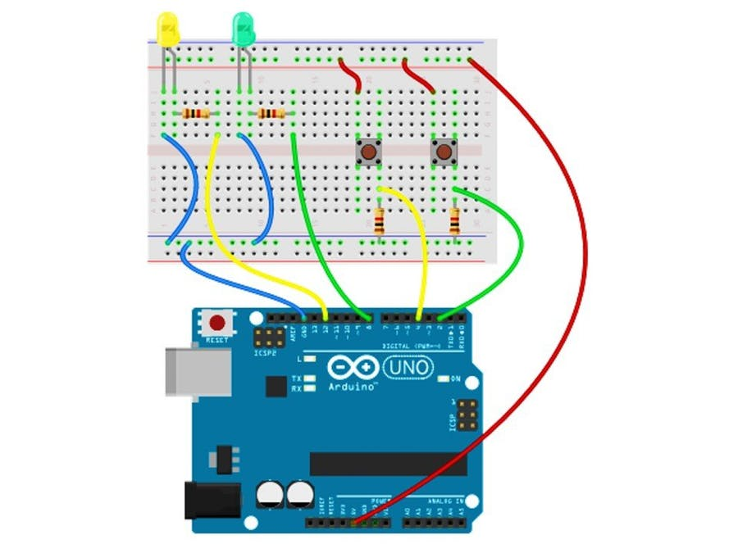

THEORY

**CONCEPT USED** :> IN IT I USED 2 LEDS AND 2 PUSSH BUTTENS , IF WE PRESS THE BUTTENS TOGETHER THEN GREEN LED WILL TURN ON AND IF WE PRESS SINGLE BUTTEN THEN RED

LED WILL TURN ON.

**Sourcecode**

const int BUTTON1 = 2;

const int BUTTON2 = 4;

const int LED1 = 8;

const int LED2 = 12;

int BUTTONstate1 = 0;

int BUTTONstate2 = 0;

void setup()

{

pinMode(BUTTON1, INPUT);

pinMode(BUTTON2, INPUT);

pinMode(LED1, OUTPUT);

pinMode(LED2, OUTPUT);

}

void loop()

{

BUTTONstate1 = digitalRead(BUTTON1);

if (BUTTONstate1 == HIGH)

{

digitalWrite(LED1, HIGH);

}

else{

digitalWrite(LED1, LOW);

}

BUTTONstate2 = digitalRead(BUTTON2);

if (BUTTONstate2 == HIGH)

{

digitalWrite(LED2, LOW);

}

else{

digitalWrite(LED2, HIGH);

}

}

**LEARNING AN OBSERVATION** :> I LEARNED THE USE OF LED AND WITH IT I CAN TURN ON AND OFF LED ACCORDING OT MY WISH . IN THIS EXPERIMENT I OBSERVED THAT IF I PRESS 2 BUTTEN

TOGETHER THEN GREEN LED WILL GROW OTHER WISE RED LED WILL GROW.

**PROBLEMS AND TROUBLE**:> PROBLEM COME WHILE , CONNECTING ARDUINO AND LEDS , RESISTORS , BUT AFTER SOME TRY I SUCCESSFULLY CONNECTED THE CIRCUIT.

**Precations** :> ONE SHOULD CONNECT THE WIREING PROPERLY AND SHOULD CONNET IT TO PROPER ARDUINO PORTS TO SUCCESSFULLY CARYOUT THE EXPRIMENT. ONE SHOULD THAKE

CARE THAT THE SENSERS WHICH ONE IS USING SHOULD WORD PROPERLY AND TAKE CARE OF

THE RESISTOR TOO DON’T USE HIGH RESISTOR .

**LEARNING OUTCOMES** :> I HAVE LEARNED THE CONTROL OF LEDS AND LEARNED HOW

TO CONTROL LED WITH BUTTENS USING ARDUINO , I HAVE LEARNED WHO TO CONNECT THE CIRCUIT OF LEDS THROUGH BREADBOARD.

UID 19BEC1052